Project partners:
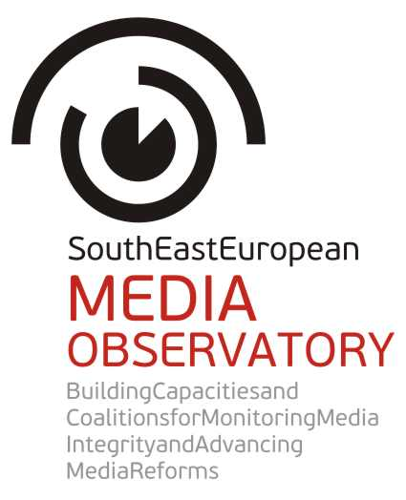 |  | 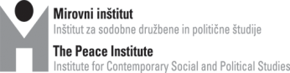
 |  | 
 |  | 
 |  | 
 |  | 
 |  | 
 |  | 

Central regional conference of the SEE Media Observatory:
“Media and journalism in South East Europe –
Captured by particular interests or turning to serve the public?”

12-13 June 2014
Tirana, Albania

With the support of Central European Initiative (CEI)
and Technical Assistance for Civil Society Organisations (TACSO)

Aims: Central regional conference of the South East European Media Observatory aims at presentation and discussion on the findings of the media integrity research and investigative journalism projects in Albania, Bosnia and Herzegovina, Croatia, Macedonia and Serbia. The research employed a concept of media integrity to analyse and understand why the media (systems) in the region of SEE are as they are, and what influence their ability to serve public interest and democratic processes. The research applied a holistic approach, exploring media policy development and implementation, media ownership, media finances and public service broadcasting as well as situation of journalists and journalism. In the research methodology, 64 risks for media integrity have been identified to guide the researchers in their analyses.
The research was conducted between July 2013 and February 2014. In addition to the research, SEE Media Observatory supported 6 investigative journalism teams to conduct own research on corrupt practices in the media sector. More than 100 relevant actors have been consulted on media integrity issues through interviews and focus groups discussions. The research findings will be published in the book which will be distributed at the central regional conference, while partners will also publish the research findings in own language, and discuss them on national level.
The central regional conference in Tirana comes 10 years after the Bled conference, organized on 11-12 June 2004 at the end of the previous regional research of the network SEENPM “Media ownership and its impact on media independence and pluralism”. This time distance allows good opportunity for comparison.

Draft agenda
Thursday, 12 June 2014

9.00-9.30 Opening session

Chairperson: Remzi Lani, Albanian Media Institute, Albania

Opening statements: Gentian Elezi, Deputy Minister of European Integration, Republic of Albania Clive Rumbold, Delegation of the European Union to Albania
Speaker: Brankica Petković, Peace Institute, Ljubljana
“SEE Media Observatory: Why to research, protect and promote media integrity?”

9.30-11.00 Session 1

Media policy development and implementation: who rules and why legislation doesn’t work?

Chairperson/discussant: János Horvát, journalist, president of the Board of the Center for Independent Journalism, Hungary

Keynote speakers: Helena Popović, Faculty of Political Sciences, Zagreb, Croatia Snežana Trpevska, School of Journalism and PR, Skopje, Macedonia (both authors of the media integrity research reports)
Panelists:
Saša Mirković, Ministry of Culture and Information, Serbia
Helena Mandić, Communication Regulatory Agency, BiH
Milaim Fetai, Agency for Audio and Audivisual Media Services, Macedonia
Gent Ibrahimi, Institute for Policy and Legal Studies, Albania

Open discussion

11.00-11.30 Break

11.30-13.00 Session 2

Media ownership – main patterns and risks for media integrity

Chairperson/discussant: Sandra B. Hrvatin, Faculty of Humanities, Koper/Capodistria, Slovenia SEE Media Observatory Advisory Board member

Keynote speaker: Sanela Hodžić, Media Center Sarajevo, BiH, author of the media integrity research report for Bosnia and Herzegovina

Panelists:
Nataša Tešanović, director, ATV, Banja Luka, BiH
Željko Ivanović, managing editor, co-owner, Vijesti, Montenegro
Meri Jordanovska, investigative journalist, Macedonia, sub-grantee of SEE Media Observatory
Vaclav Štetka, Charles University, Czech Republic, author of the 2013 Oxford research on media ownership in CEE
Andrew Finkel, P24 – Platform for Independent Journalism, Turkey

Open discussion

13.00-14.30 Lunch

14.30-16.00 Session 3

Media finances – is there a media market at all? To blame the industry or the state?

Chairperson/discussant: Saša Leković, Investigative Journalism Center, Zagreb
Keynote speaker: Ilda Londo, AMI, Tirana, author of the media integrity research report for Albania

Panelists:
Senad Zaimović, president, Joint Industry Committee, Fabrika Agency, BiH
Besar Likmeta, investigative journalist, BIRN, Albania, sub-grantee of SEE Media Observatory
Agron Bajrami, editor, Koha Ditore, Kosovo
Mladen Čadikovski, director, Fokus weekly, Macedonia
Milan Živković, head of the Media Department, Ministry of Culture, Croatia
Goran Klemenčič, former president of the Anti-corruption Commission, Slovenia

Open discussion

16.00-16.15 Break

16.15-17.45 Session 4

Public service broadcasting: governing and financing patterns - way of control and way of solution?

Chairperson/discussant: Marko Milosavljević, Faculty of Social Sciences, Ljubljana, Slovenia
Keynote speaker: Dubravka Valić Nedeljković, Novi Sad School of Journalism, Serbia, co-author of the media integrity research report for Serbia

Panelists:
Sanja Mikleušević Pavić, news editor, HRT, Croatia
Mehmed Agović, adviser, Ministry of Transport and Communication, former DG of BHRT
Lutfi Dervishi, media expert, former news program editor at TVSH, Albania
Harun Ibrahimi, deputy director general, MRT, Macedonia
Radka Betcheva, EBU Partnership Programme

Open discussion

19.30 Dinner in the city

Friday, 13 June 2014

9.00-11.00 Session 5

Journalists - Victims or constituents of structures and relations which obstruct democratic role of the media?

Chairperson/discussant: Boro Kontić, Media Center Sarajevo, BiH

Keynote speaker: Jovanka Matić, Institute of Social Sciences, Belgrade, co-author of the media integrity research report for Serbia

Panelists:

Duška Jurišić, journalist and editor, FTV BiH
Tamara Causidis, president, Union of Journalists, Macedonia
Ilva Tare, journalist, Ora News
Yavuz Baydar, P24 – Platform for Independent Journalism, Turkey
Marijana Camović, Union of Journalists, Montenegro
Balazs Weyer, president, Hungarian Editors Forum, Budapest

Open discussion

11.00-11.15 Break

11.15-12.45 Session 6

External view and context: are media integrity problems a regional or wider problem?

Chairperson: Ilona Moricz, Center for Independent Journalism, Budapest, Hungary
Keynote speaker: Aidan White, Ethical Journalism Network, SEE Media Observatory Advisory Board member
Panelists:
Guy Berger, Division of Freedom of Expression and Media Development, UNESCO
Karl Giacinti, European Commission, DG Enlargement
Leon Willems, Global Forum for Media Development
Ross Biggam, Association of Commercial Television in Europe
Ewen MacAskill, The Guardian, UK

Open discussion

13.00-14.00 Closing session:

Prospects for media integrity in SEE: Positive cases and Recommendations

Chairperson/discussant: Gordana Janković, head of Media Department, OSCE Mission to Serbia
Keynote speaker: Sandra B. Hrvatin, Faculty of Humanities, Slovenia, SEE Media Observatory Advisory Board
Panelists:
Gordana Igrić, director, Balkan Investigative Reporting Network
Oliver Vujović, director, SEEMO
Biljana Petkovska, director, Macedonian Institute for Media
Remzi Lani, director, Albanian Media Institute
Brankica Petković, Peace Institute, Ljubljana, SEE Media Observatory project coordinator

Open discussion

14.00 Lunch

End of conference.

In 2013 and 2014 the SEE Media Obervatory activities have been supported by the Open Society Foundations Program on Independent Journalism, Konrad Adenauer Stiftung Media Program for South East Europe, Open Society Foundation Serbia, Office for Cooperation with NGOs within the Government of the Republic of Croatia, Government of the Autonomous Province of Vojvodina, Department for International Development Cooperation Policies of the Ministry of Foreign Affairs in Slovenia, and the Guardian Foundation.

